UPDATE FIRMS TO VERSION 19

Send to: Tabs3 only clients (no PracticeMaster)
Writing for: Office Managers
Call to action: Reply to schedule a demo of new v19 features

Subject: Tabs3 has a new feature that you should see

Actually, it has several! The latest version of Tabs3 software was just released. Here are screenshots of two of my favorite new features.

- PracticeMaster Dashboard – quick access to your schedule, tasks and time that you’ve billed

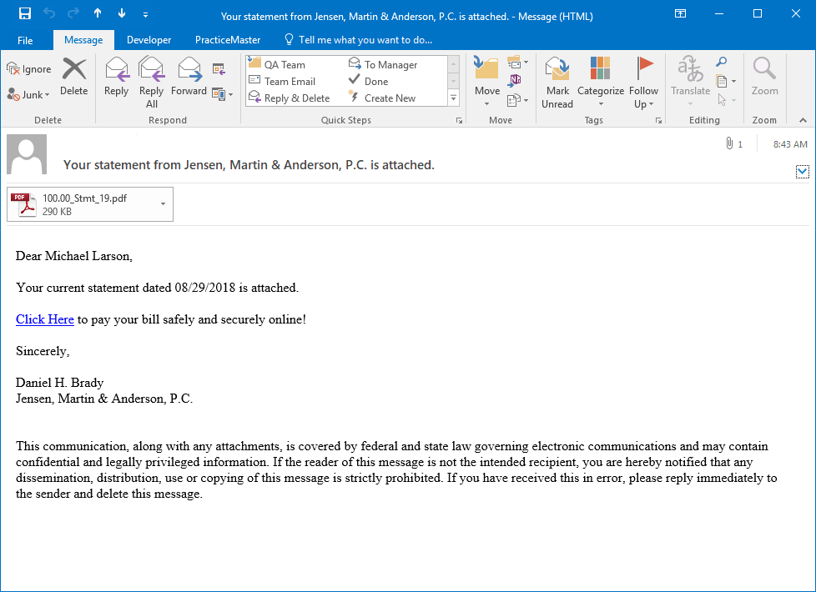
- Online payments – can automatically include a payment link when you email statements to your clients, so that they can easily pay you online.

Version 19 is a strong release. The “What’s New” list for the release includes 16 pages of new and enhanced features. I would love to help you install the update, or train your staff on the new features. Email me if you are interested, and we can discuss the new features and figure what makes sense for your firm.

I hope to hear from you soon.

[Consultant name]

