ACTIVE LEADS EMAIL

Send to: Active Tabs3 and PracticeMaster leads
Writing for: Attorneys (as opposed to office administrators, etc)
Call to action: Reply to schedule a demo of new v19 features

Subject: Tabs3 has a new feature that you should see

Actually, you should see several new features in Tabs3 Software! Version 19 was just released. Here are screenshots of two of my favorite new features.

- PracticeMaster Dashboard – quick access to your schedule, tasks and time that you’ve billed
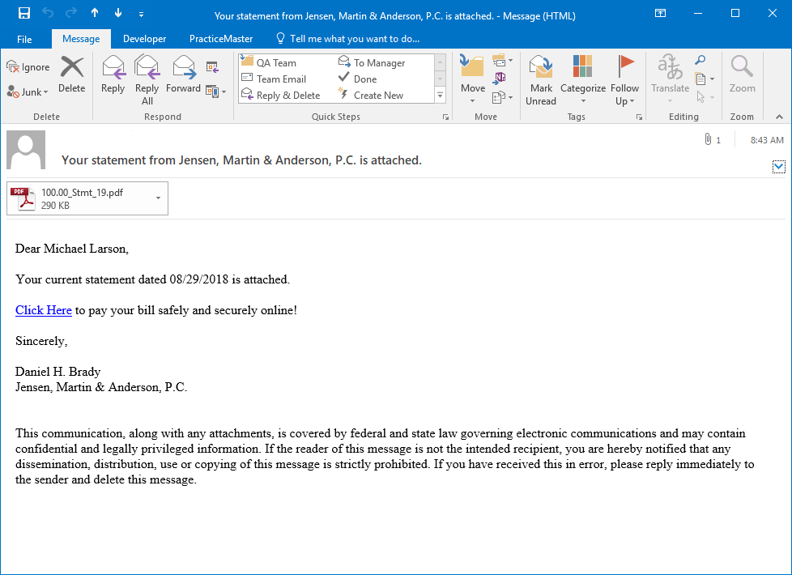
- Online payments – can automatically include a payment link when you email statements to your clients, so that they can easily pay you online.

The “What’s New” list for the release includes 16 pages of new and enhanced features. Email me, and I can point out the ones that will make the biggest difference to your firm.

I hope to hear from you soon.

[Consultant name]

